M. H. Saboo Siddik Polytechnic Website

About College:

Originally, the Institute was founded in the year 1936 as a trade school with the object of turning out artisans in some industrial arts and crafts. A major reorganization in its curriculum took place in the year 1945. In 1958, a three-year Diploma program in Civil Engineering was started and five years later, two more Diploma program in Electrical and Mechanical Engineering were added. To cope up with the increasing demand, from 1981 the Polytechnic has increased the intake capacity from 120 to 180 students. Taking into consideration, the development in Industrial Electronics in Maharashtra and Mumbai in particular, the Polytechnic started three- year Diploma in Industrial electronics from the academic year 1981-82. From the academic year 1987-88, the polytechnic has started three Year Diploma in Computer Engineering. A three-year Diploma in Information Technology & Mechanical Engineering (Un-Aided) has been approved and sanctioned by AICTE, New Delhi from the year 2000-01, 2010-11 respectively. In the year 2000 the polytechnic was awarded as “Best Polytechnic with a cash prize of One Lakh” from Chief Minister, Govt. of Maharashtra. In the year 2018- 19 the polytechnic got NBA accreditation and based on the performance the aided seats were increased from 180 to 240. In line with this objective, the institute has assured the quality in technical education by continuous up-gradation of facilities and infrastructure along with the effort to appoint qualified & eligible teachers. We have ISTE chapter, CSI chapter for students.

About Mr. M. H. Saboo Siddik

The Mohammed Haji Saboo Siddik Institute (a Minority Institute) owes its existence to the munificence of the late Mohammed, son of Haji Saboo Siddik, who bequeathed a large sum of money for establishing, conducting and managing the Institute for imparting Vocational, Technical and Industrial Training and Education. Subsequently, when the concept of technical high school took shape, a sum of Rupees One Lakh was also received from the assets of his mother, Bai Jimba Bai, after whom one of the buildings has been named in the premises of the Institute*.*

Departmental Information:

1. Year of starting of the programme : 1987
2. AICTE Approval details of the department Date of 1st approval by AICTE : 31/03/1994

Programme Details:

Nature of Programme : Full time (F) Duration : 03 Years

Sanctioned Intake : 60 (Sixty)

# Vision of the Department:

To become part of the industry and research organizations at the national and international levels and to produce competent technicians trained in the latest tools and technologies with strong academic and technical skills.

# Mission of the Department:

1. To Prepare students to be life-long learners by offering a concrete theoretical groundwork in computing along with applied computing experiences and enlightening them about their professional and ethical responsibilities.
2. To provide exposure to the latest tools and technologies in the area of computer hardware and software.
3. To provide a strong theoretical and practical background across the computer science discipline with an emphasis on software development.
4. To promote research based projects / activities in the emerging areas of technology convergence.
5. To establish Industry-Institute Interaction to make students ready for the industrial environment.

# Program Educational Objectives

* PEO1:To prepare our diploma students with latest tools and technologies and develop the ability to communicate effectively, function ethically and legally to fulfill societal needs.
* PEO2:To develop professional skills in students that prepares them for immediate employment and for lifelong learning in advanced areas of computer science and related fields.
* PEO3:Ability to function in multidisciplinary teams and to identify, formulate and solve engineering problems using software development tools through industry institute interactions.
* PEO4:To prepare and motivate students capable of designing and developing real- world computing applications leading to research and innovation with high societal influence and impact.
* PEO5:To inculcate the application of logical, mathematical and analytical reasoning in solving problem and prepare them to proactively engage in research and life- long learning.

Staff Data:

|  |  |  |  |  |
| --- | --- | --- | --- | --- |
| **Name of the faculty member** | **Qualification, Board and year of Graduation** | **Designation and date of joining the institution** | **Research paper publications** | **Years of experience** |
| **Ms.**  **Zaibunnisa Malik** | M. E. (Computer)  2005,  Mumbai University, | Regular | 5- National Conference | 25 yrs |
| Ph D.  Pursuing | HOD  Computer | 1-  International Conference |
|  | 02.2.1997 |  |
| **Mr.**  **Mohammad Ali** | M. Tech Computer, | Lecturer, Sel. Grade | 1- National Journal | 23 yrs |
| A. A. I. D. U., 2006, | 01/02/1999 |
| Ph D.  Pursuing |  |
| **Mrs. Kausar Ayub Akumalla** | M. Tech Computer | Lecturer, Sel. Grade | 1- National Journal | 23 yrs |
| A. A. I. D. U. University  2007, | 13/08/1999 |
| Ph D.  Pursuing |  |

|  |  |  |  |  |
| --- | --- | --- | --- | --- |
| **Mrs.**  **Shafaque**  **M. Islam** | M. E. Computer, Mumbai University,  2017 | Lecturer, Sr.  Grade | 2-  International Journal | 15 yrs |
| 07/08/2007 |
| **Mr. Khan Mohammed Zaid Shahid Akhtar** | M. E. Computer, Mumbai University,  2016 | Lecturer | 1-  International Journal | 8 yrs |
| 01/01/2014 |

Staff Journal Papers

# Ms. Zaibunnisa Malik:

1. “A study on Data Mining”, National Conference on Research Practices in current areas of Information Technology (RPIT), March 2004.
2. “A study of Data Warehouse”, National Conference on Research Practices in current areas of Information Technology (RPIT), March 2004.
3. “Dynamic Website”, National Conference on Research Practices in current areas of Information Technology (RPIT), March 2004.
4. “Fault Detection & Diagnosis”, National conference Trends of Computational Techniques in Engineering (TCTE), October 2004.
5. “Playground Status using Web Page Content Mining”, National conference on Sun Rising Technology (NCSRT), October 2005.
6. ”Cost Estimation and Analysis of Computing Models in Education”, International Conference on Trends in Electronics and Informatics (ICEI), May 2017.

# Mr. Mohammad Ali

1. “The World of Artificial Life: FRAMSTICKS”, National Conference on Emerging Trends in Computers, Communication & Information Technology, March 2009.

# Mrs. Kousar Ayub Akumalla

1. “The World of Artificial Life: FRAMSTICKS”, National Conference on Emerging Trends in Computers, Communication & Information Technology, March 2009.

# Mrs. Shafaque M. Islam

1. “Data Representation approach for Class time tabling problem with genetic algorithm”,International Journal of Modern Trends in Engineering & Research (IJMTER), Volume 3, Issue 8, August 2016.
2. “Modified GA to get near optimal solution for class time table problem”,

IJIRCCE, Volume 4, Issue 11, November 2016.

# Mr. Khan Mohammed Zaid Shahid Akhtar

1. “A Mobile Application for Quick Classification of Plant Leaf Based on Color and Shape”,

International Journal of Modern Trends in Engineering & Research (IJMTER), Volume 2, Issue

10, October 2015

# Staff Training

**Ms. Zaibunnisa Malik:**

1. Attended 5 days faculty development training programme on „Outcome Based Education of NBA and SAR writing Techniques‟ from 19/12/16 to 23/12/16 at M.

H. Saboo Siddik Polytechnic.

1. Participated in paper presentation International Conference on Trends in Electronics and Informatics (ICEI) organized by SCAD College of Engineering and Technology, Tirunelveli, India on 11-12th May 2017

# Mr. Mohammad Ali:

1. Attended 6 days faculty development training programme on “Internet of Things and Its Applications” from 2/01/2017 to 7/01/2017 at K. J. Somaiya Polytechnic, Vidyavihar

# Mr. Khan Mohammed Zaid Shahid Akhtar

1. Attended 6 days Induction Training Phase-I Programme from 18/05/2015 to 29/05/2015 organized by St. Xavier Technical Institute, Mahim.
2. Attended 6 days Induction Training Phase-II Programme from 06/06/2016 to 17/06/2016 organized by Bharti Vidyapeeth Institute of Technology, Navi Mumbai.
3. Attended faculty development training programme “Introduction to LINUX & Allied Tech.” from 23/01/2017 to 28/01/2017 organized by M. M. Babasaheb Gawde Institute of Technology, Mumbai Central.

# Mrs. Shafaque Julaha

* 1. Machine Learning using smart devices, ISTE approved, Duration 04/02/2019 to 08/02/2019, organized by Vidyalankar Polytechnic.

# Department Professional Activities:

**INDIAN SOCIETY FOR TECHNICAL EDUCATION (ISTE):**

All the regular faculty members are having LIFE MEMBERSHIP (LMISTE) of Indian Society of technical Education .The staff and student participate in various faculty development programs, refresher courses ,Technical Paper presentation, Quiz competitions etc. Through ISTE News bulletin awareness is created amongst the student and staff about their activity schedule. Staff and student are encouraged to take active participation in all ISTE activities.

# COMPUTER SOCIETY OF INDIA (CSI):

Most of the student are having the MEMBERSHIP of CSI.The student participate in various development programs, refresher courses, Technical Paper presentation, Quiz competitions etc. Students are encouraged to take active participation in all CSI activities.

# INDUSTRY INSTITUTE INTERACTION CELL:

Computer engineering department is having a wide network of their Industry channel partners. Their names and extent of industry support is given below

1. CYBERNET TECHNOLOGIES
2. NEXGEN MARKETING
3. SNOW COMPUTERS
4. IRIX ELECTRONICS
5. KGN COMPUTER
6. WESTERN COMPUTER
7. COMPUTER HOUSE
8. ZEETRONICS
9. IMPACT INFOTECH
10. SYSCON COMPUTER SYSTEM
11. TIKONA DIGITAL NETWORKS
12. WEST ZONE
13. SAIF INFOTECH
14. QUADRA INFOTECH
15. CYBER NET
16. ADIL COMPUTER
17. FORBES TECHNOSIS LTD
18. LIMRA,SYSCON COMPUTERS
19. SAIF INFOTECH
20. QUADRA INFOTECH,
21. SWASTIK E-SOLUTION
22. SILICON INFOTECH AND
23. CRYSTAL COMPUTER SERVICES

DEPARTMENT LEVEL EVENTS:

On 05/07/2022, State Level Workshop on Cyber Security was organized. It was organized by Mrs. Kousar Akumalla, Sel. Gr. Lecturer & Mrs. Shafaque Julaha, Sr. Lecturer Computer Engineering. The total number of beneficiaries were 54 (51 from MHSSP & 03 from Other institute).

**Workshop on “Cyber Security” Photos :**

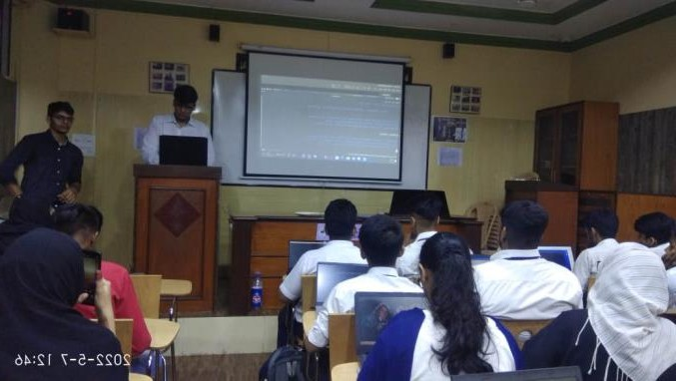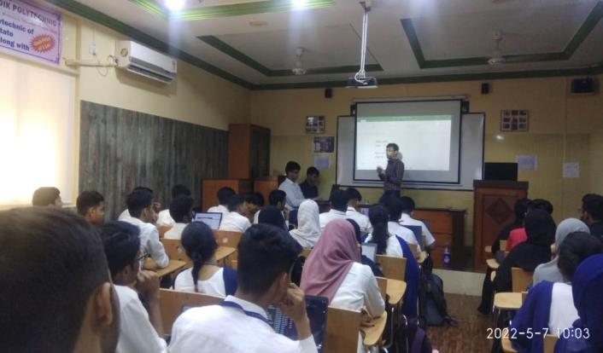

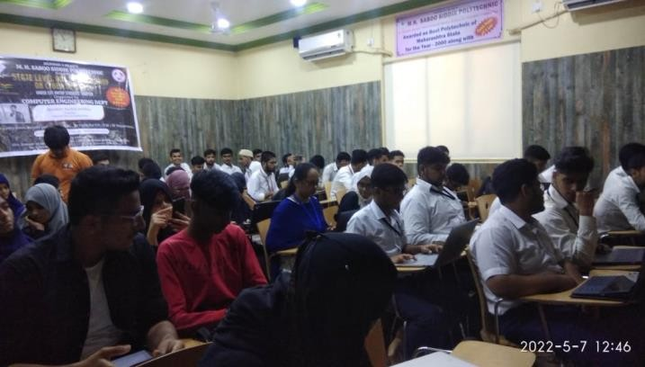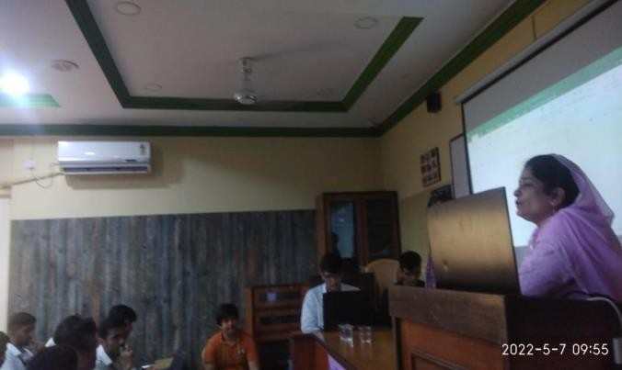

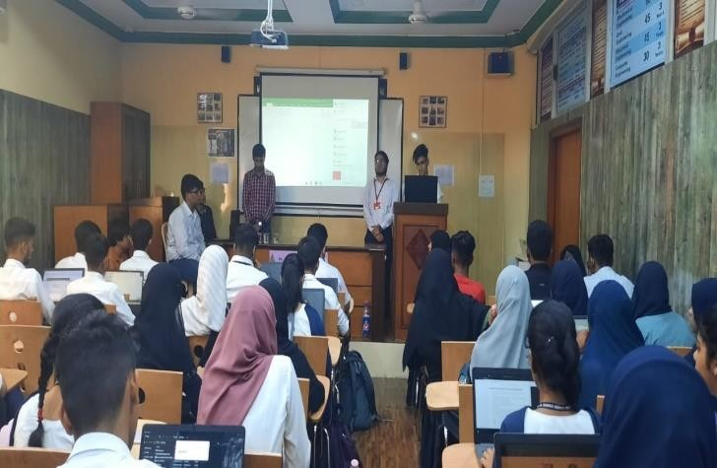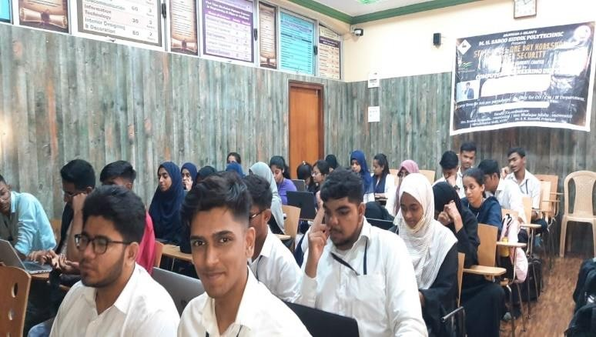

On 20/04/2022, State Level Workshop on Ethical Hacking was organized. It was organized by Mr. Mohammad Ali, Sel. Gr. Lecturer & Mr. Khan Mohammed Zaid, Lecturer Computer Engineering. The total number of beneficiaries were 80 (66 from MHSSP & 14 from other colleges)

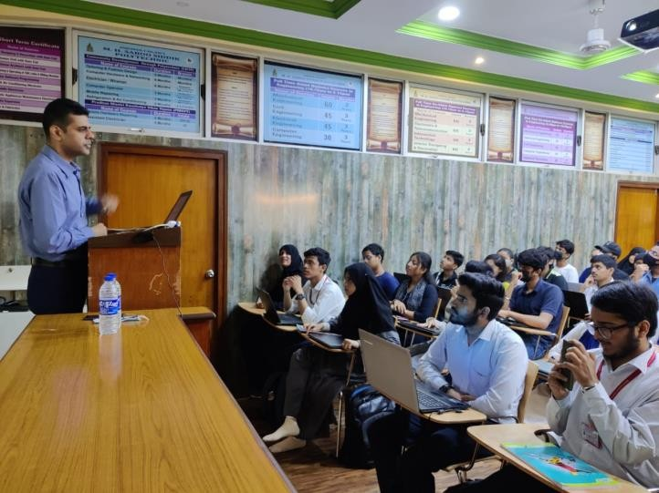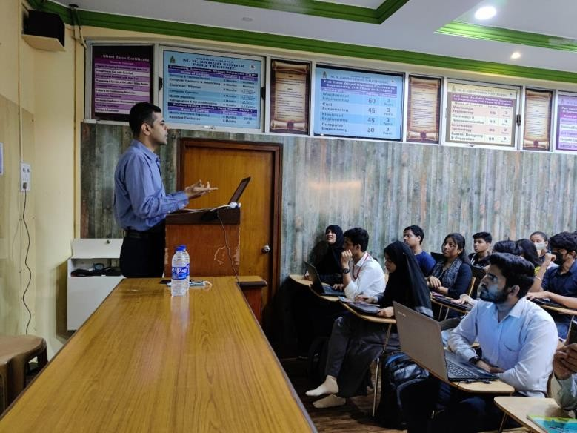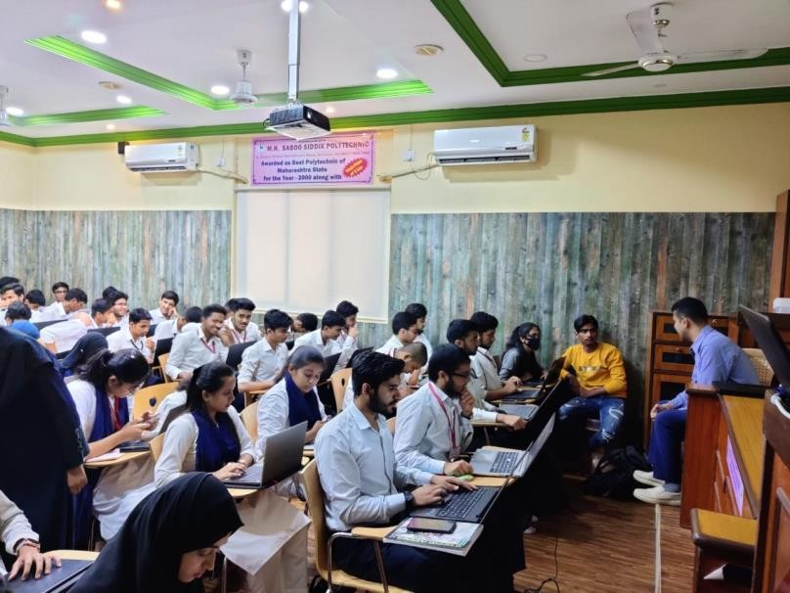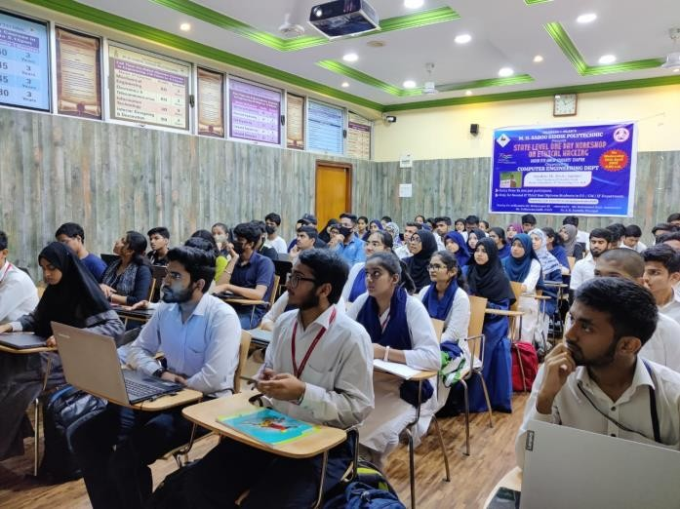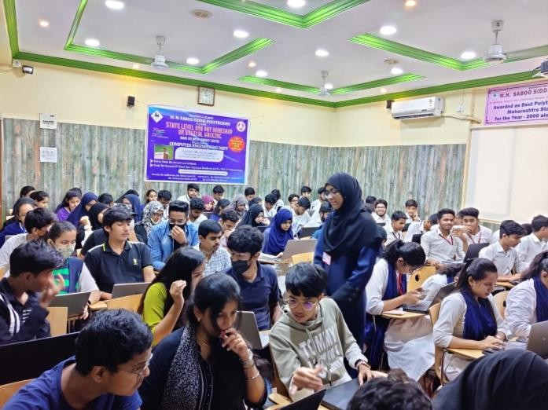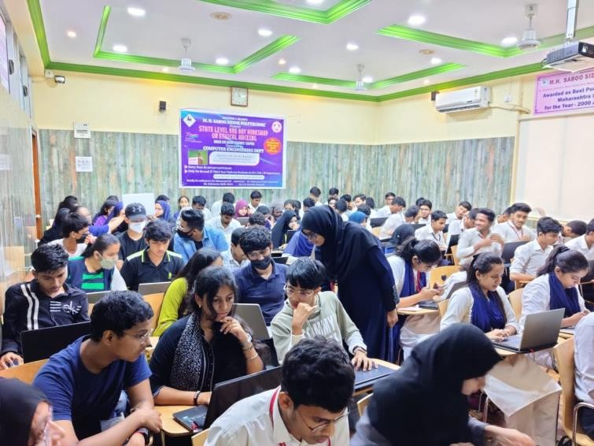

On 04/07/2021, State Level Coding Competition using “C” was organized. It was organized by Mr. Mohammad Ali, Sel. Gr. Lecturer & Mr. Khan Mohammed Zaid, Lecturer Computer Engineering. The total number of beneficiaries were 94 (54 from MHSSP & 40 from other colleges)

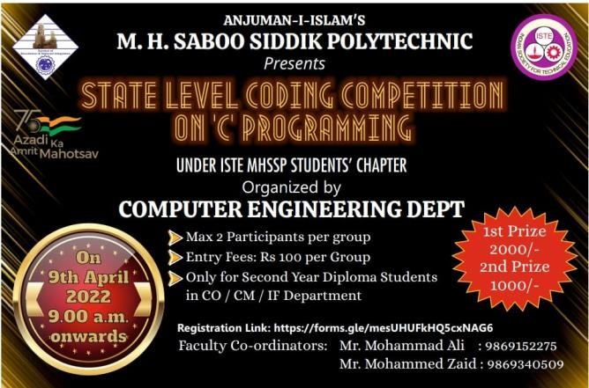

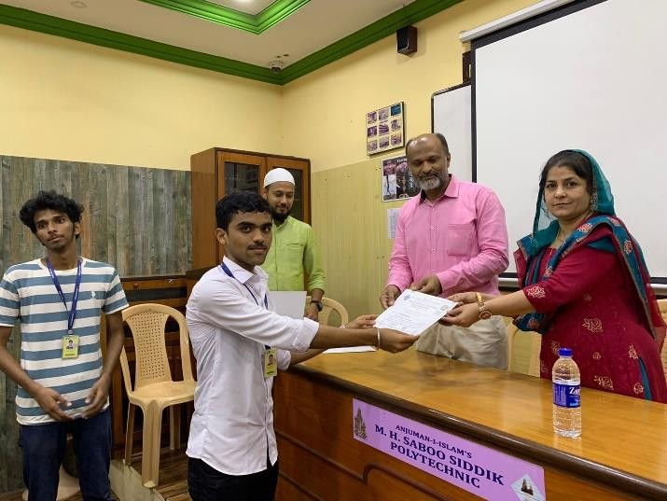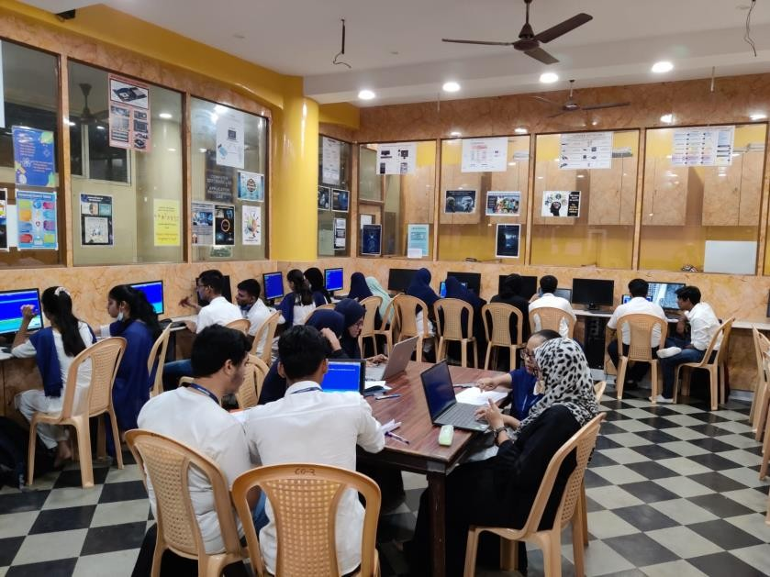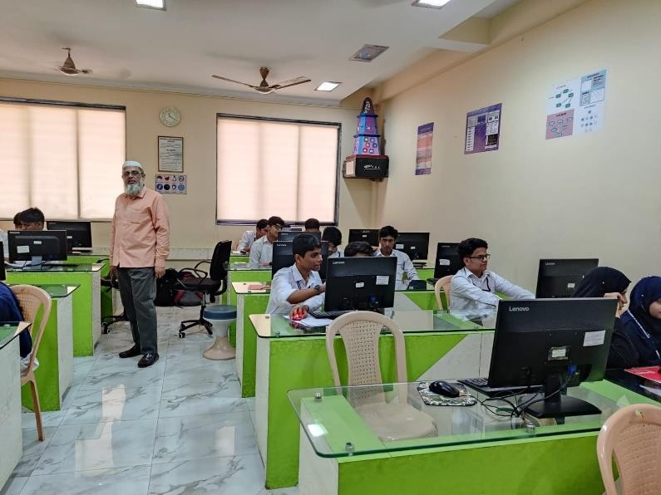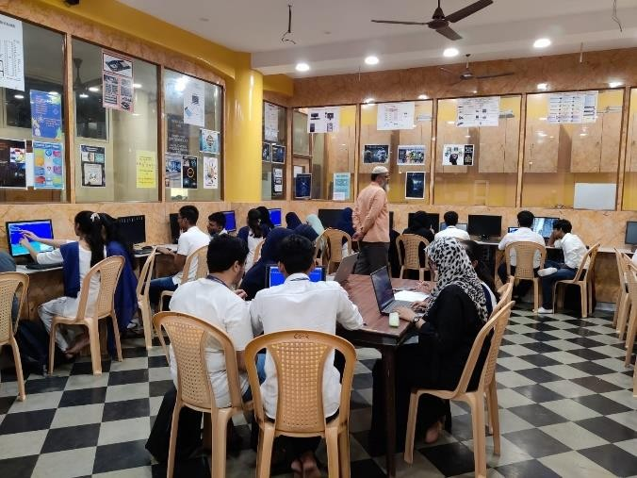

On 11/12/2021, State Level Technical Quiz Competition was organized. It was organized by Mrs. Shafaque Julaha, Sr. Lecturer & Mr. Khan Mohammed Zaid, Lecturer, Computer Engineering. The total number of beneficiaries were 58.

